For immediate release 22nd December 2019

**Dubai Duty Free Celebrates 36 Years of Retailing Service**

* ***Three Day Anniversary sales topped Dhs209.48 million (US$57.39 million)***

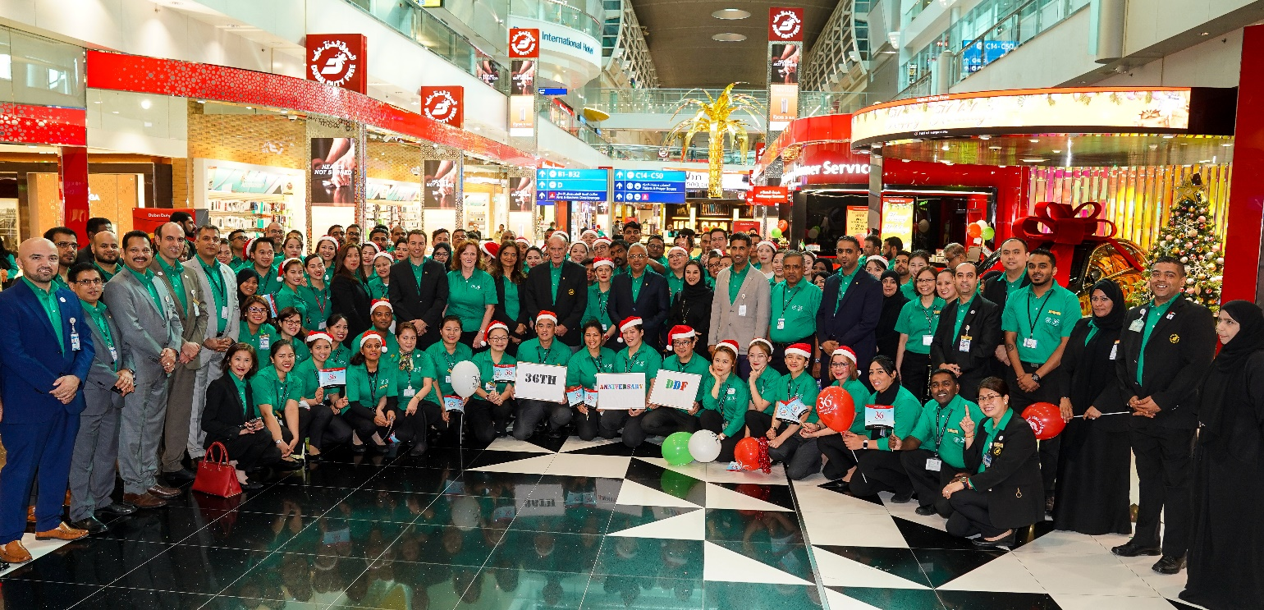

**Dubai Duty Free management and staff celebrating its 36th anniversary in Concourse C, Dubai International Airport.**

Dubai Duty Free marked its 36th anniversary in style as it welcomed passengers travelling through Dubai with a special 25% discount on a wide range of merchandise over three days which began at midnight on 18th December (Wednesday) and continued until the operation’s anniversary day on 20th December, Friday. Total sales for the three days reached Dhs209.48 million (US$57.39 million).

The anniversary discount for 72 hours resulted in a spending spree at Dubai International and at Al Maktoum International airports with sales figures on 18th December reaching Dhs49.83 million (US$13.65 million) and Dhs47.99 million (US$13.15 million) on 19th December.

On the anniversary day itself, 20th December, Dubai Duty Free daily sales reached Dhs111.65 million (US$30.59 million).

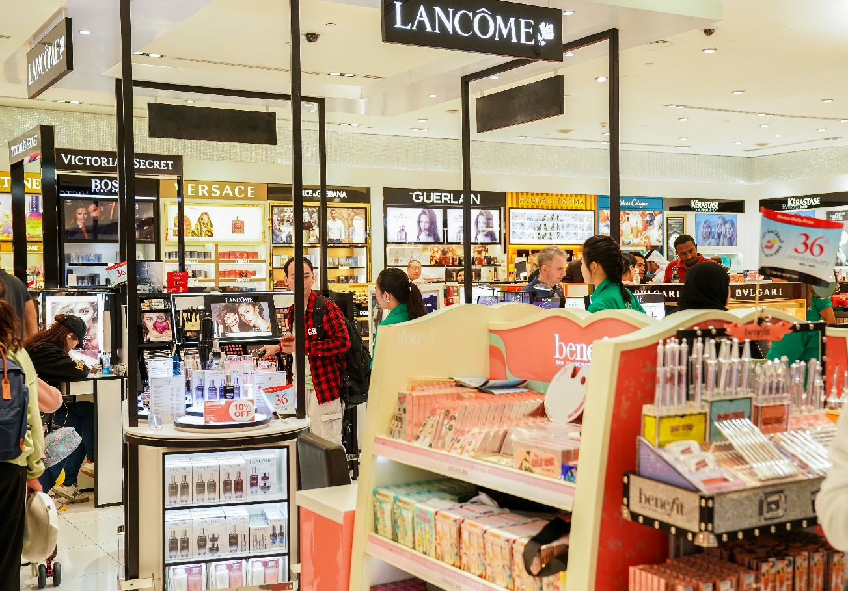

From a category point of view, Cosmetics was the highest selling category with sales of Dhs54.80 million (US$15.02 million) during the three-day period followed by Perfumes with sales of Dhs37.55 million (US$ 10.29 million) and Watches with Dhs33.35 million (US$9.14 million) sales.

Commenting on the success of 36th anniversary, Colm McLoughlin, Executive Vice Chairman and CEO of Dubai Duty Free said: “The anniversary celebrations spread over three days were fantastic and received positive results across all the concourses. I would like to thank everyone, in particular thanks to our customers and our staff who did a great job in serving the high number of passengers.”

During the three-day 36th anniversary sales, Dubai Duty Free’s Distribution Centre issued 2,532 pallets of merchandise and conducted 240 trips from the warehouse to the airport.

The highest number of pallets was issued on 19th December with 931 pallets being delivered in 88 trips.

The total number of picks in the warehouse during this period was 25,637 for 923,182 units of merchandise, with the highest picks on 18th December for 418,787 units of merchandise.

Over the three-day period (18th, 19th and 20th December), the cash registers recorded a total of 358,523 sales transactions with 190,208 transactions alone on 20th December.

The Dubai Duty Free anniversary promotion is now a highly-anticipated event with many travelers choosing to travel on the days when the 25% discount is offered. The first anniversary sale Dubai Duty Free introduced was on its 20th Anniversary in 2003.

The 36th anniversary also saw a series of celebrations in various locations over the past week led by Colm McLoughlin, Executive Vice Chairman & CEO, Ramesh Cidambi, Chief Operating Officer, Salah Tahlak, Executive Vice President-Corporate Services together with the other members of the executive team. The activities also attracted a few well-known faces such as Noha Nabil, a Kuwaiti style icon and social media influencer who joined the Dubai Duty Free officials to celebrate in Concourse A, while Wimbledon Champion and World No. 4 tennis player Simona Halep joined the Dubai Duty Free group in Concourse D.

The Dubai Duty Free staff also enjoyed a total of Dhs85,000 cash prizes in the ‘Staff Surprise’ draw. In addition, the executive team also awarded a Certificate of Appreciation to long-serving employees who have been with the company for 25 years, 30 years and 35 years.

Dubai Duty Free currently employs 6,100 staff and of the original 100 staff who joined in December 1983, 25 remain in active service and are referred to as the ‘Pioneers’.

* Ends   -

For further information, please contact the Marketing Department,

Dubai Duty Free, PO Box 831, Dubai, UAE.

Tel: +9714-6019225 or email: [chirstine.feliciano@ddf.ae](mailto:chirstine.feliciano@ddf.ae)